Name: Christina DiMicelli Dates (Allocated Time): 8-9 weeks
1-50min period/wk
Unit Topic:/Title: Digital Footprints Grade Level: 7

Content Standard(s):

ISTE NETS*S
Digital Citizenship
Students understand human, cultural, and societal issues related to technology and practice legal and ethical behavior.

Creativity and Innovation
Students demonstrate creative thinking, construct knowledge, and develop innovative products and processes using technology.

Technology Operations and Concepts
Students demonstrate a sound understanding of technology concepts, systems, and operations.
http://www.iste.org/standards/nets-for-students.aspx

NH Curriculum Framework for the Arts
Visual Arts K-12, Curriculum Standard 6
Students will make connections among the visual arts, other disciplines, and daily life.
http://www.education.nh.gov/instruction/curriculum/arts/documents/frameworks.pdf pg. 33

Learning Unit Overview:
“On the Internet a digital footprint is the word used to describe the trail, traces or "footprints" that people leave online. This is information transmitted online, such as forum registration, e-mails and attachments, uploading videos or digital images and any other form of transmission of information — all of which leaves traces of personal information about yourself available to others online.” (Webopedia, n.d.)

Middle school students are very active on the internet and are beginning to experiment more deeply with social media. They may be unaware that every action taken on the internet leaves a footprint that is digitally connected to their identity. In this unit of study they will learn about what digital footprints are and review where online they are leaving their own set of footprints. Through art integration projects, students will physically feel the process of creating footprints. They will also create their own avatars (visual representation of themselves) and connect these to online safety procedures. Online games will reinforce the content regarding digital citizenship. The students will come together to create a large mural-like poster containing their collaborative “digital pledge”. Finally, in a move to “pay it forward”, students will create audio PSAs (Public Service Announcements) for our Lower School students.

Brain Target #1
Emotional Connection:

Several activities throughout the unit expand upon the emotional connection students have to their online identities. It is a very personal experience to be an online identity that leaves footprints behind.

Students will create products that are very personal and full of identity:
- Footprint banner (real footprints created for emotional/physical connection to the content)
- Avatar (digital representation of self)
Avatar example
(from Wimp Yourself)

Teacher participates in brainstorming activities to share their experiences with online presence with students thereby connecting with students.

Students will work together on a group collaboration product in which they identify how to be responsible to themselves and each other online (friends, peers, etc. are powerful emotional triggers online). Included is an art hands-on activity in which their handprints will be added to a Digital Pledge Mural.

Students will create an audio project that includes their own voices and choice of background mood music (Public Service Announcement). Different emotions can be evoked through the choice of background mood music.

Brain Target #2
Physical Environment:

Several activities throughout the unit produce tangible products. These will be hung on the classroom walls. At the culmination of the unit students will present their audio PSAs to the Lower School (LS) and the Digital Pledge Mural will be moved to a hallway in that part of the school. Teachers will have the opportunity to have LS students add their handprints to the mural.
- Footprint banners
- Avatars
Digital Pledge Mural example
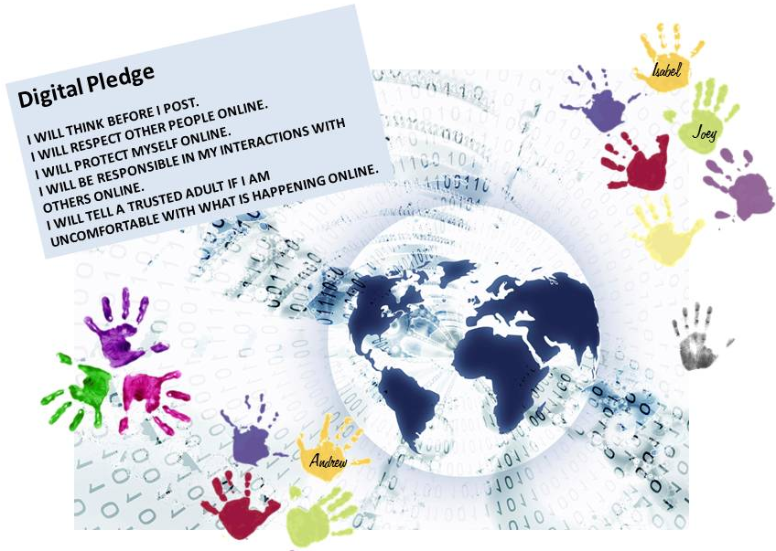
- Digital Pledge Mural
Digital Pledge Mural example

A bulletin board with relevant articles and images relating to digital citizenship/footprints will be on the classroom wall. Students are encouraged to add to the collection with their own findings.

Beach themed borders will encircle the classroom (waves, sand, etc.) to connect with the “footprints”.

Brain Target #3
Concept Map / Advanced Organizer:

A footprint concept map will be on the classroom wall and introduced to students at the beginning of the unit.

Students will utilize brainstorming/organizers when collaborating on the Digital Pledge contents.

During the PSA activity, students will storyboard their message visually before accessing the technology components.

Learning Goals:

- Students will understand the concept of digital footprint.
- Students will demonstrate an understanding of digital identity and how their own activities online create a unique and personal set of digital footprints that connect to their digital identity.
- Students will demonstrate an understanding of internet safety procedures and netiquette.

Introductory “Big Picture” Activity/Assessment of Prior Knowledge:

- Ask students if they have heard of the phrase “digital footprint” and ask for input as to what they believe it could mean. Write key points on whiteboard and come to a class consensus on the definition.
- Watch the video Digital Dossier regarding Andy and his life (birth to death) from a digital standpoint. Students think-pair-share regarding the question “how aware are you of the digital tracks you leave behind?”
- Overall class discussion regarding how to protect privacy online and netiquette guidelines follows with key points on whiteboard.
- Students brainstorm, individually, a list of all the tracks they leave behind and create a recording of their personal digital footprints.

Brain Target #4
Activities for Teaching Mastery of Declarative/Procedural Knowledge:

Footprint Banner
With help from the Art teachers and in the Studio space, students will create banners. With bare feet and paint, they will make a footprint trail of 3-4 prints. When dry, students will utilize the recording of their personal digital footprints (from BT#3 earlier) and creatively write the items all over the banner. Space should be kept clear on the banner to add a printed image (avatar) later in the unit. Banners will be designed to hang around the classroom.

Online Games
Students will spend time playing the games on the Media Awareness Network (Privacy Playground) to reinforce ideas and guidelines discussed.

Avatar
Ask students if they have heard of the term “avatar” and ask for input as to what they believe it could mean. Come to a class consensus on the definition. Discuss the benefits (online privacy) to utilizing an avatar, writing key points on whiteboard. Students will create their own avatar, print it out, and affix it to their personal footprint banner.
Footprint Banner example
(prior to avatar addition)

Brain Target #5
Activities for Extension and Application of Knowledge:

Digital Pledge Mural
Create groups of 3-4 students. Using the key points identified for protecting online privacy and netiquette guidelines (BT#3 earlier), student groups will discuss and create guidelines for a Digital Pledge (utilizing visual organizers). Groups will share ideas and the class will come to a consensus on a collaborative pledge.

With the help from the Art teachers and in the Studio space, students will create a Digital Pledge Mural. This will consist of a center artwork that visually showcases their ideas, the pledge itself, and handprints of each student along with their signature. An official pledge ceremony should accompany the signature portion of the mural creation culminating in the mural being put on the classroom wall.

Audio PSAs (Public Service Announcements)
Working in pairs, students will storyboard an audio PSA for a Lower School (LS) audience on a teacher-approved topic within the unit focus. Utilizing the Web 2.0 resource Aviary, students will create a PSA that includes voice and background mood music to convey their message. When PSAs are presented to the LS, the Digital Pledge Mural may be moved to a LS hallway where younger students can also add their signatures to the artwork (LS teachers may need materials to convey topic in more depth to the younger students).

Brain Target #6
Evaluating Learning:

Introductory “Big Picture” Activity
- Checking for Fog – Ask students to write on a piece of paper what part of the activity was most unclear (foggy) to them as their “ticket out the door”.

Footprint Banner
- Student self-assessment
- Checklist (developed in conjunction with Art teacher)

Online Games
- Back-to-Back – In pairs students stand back-to-back, each with notebook and pencil. The teacher asks a question regarding the topic and students write answers in the notebooks. Teacher will instruct students to turn around, show partner answers, and discuss.

Avatar
- Slogan – Ask students to create a slogan that captures the main idea of the activity and matches their avatar.

Digital Pledge Mural
- Checklist (developed in conjunction with Art teacher)
- Student self-assessment

PSAs
- Student self/group assessment
- Peer reviews
- Rubric
- Storyboard

Culminating
- Reflection survey – students complete an online survey that contains reflection prompts and questions regarding the unit topic and activities.

References

What is digital footprint? - A Word Definition From the Webopedia Computer Dictionary. (n.d.). Retrieved March 1, 2012, from http://www.webopedia.com/TERM/D/digital_footprint.html

Resources

Digital Dossier Video
http://www.youtube.com/watch?v=79IYZVYIVLA

Privacy Playground: The First Adventure of the Three CyberPigs
http://www.media-awareness.ca/english/games/privacy_playground/index.cfm

Options for creating Avatars
Flower Power http://www.openrise.com/lab/FlowerPower/
Wimp Yourself http://www.wimpyourself.com/?w=5ed916929bec2de561b3035bb
Build Your Wild Self http://buildyourwildself.com/

Aviary for Education
http://www.aviaryeducation.com/

Notes

This unit focuses on digital/online privacy and netiquette. Although it may come up as a topic in discussion, Cyberbullying is not covered in-depth.

The Computer Lab is next door to the Art Studio with a connecting door. It is not unusual for the Art teachers and Computer teacher to collaborate and work on cross-curricular projects.

Although the Privacy Playground game is designed for a slightly younger audience, it can still be useful for this age group as a basic knowledge set. It could be helpful to remind students that they will be informing younger classmates about these issues, therefore looking at the data through a slightly younger lens might be beneficial.

Lead teacher may want to prepare, in advance, a basic one-sheet information flyer for Lower School teachers to prepare younger students for PSA information and knowledge about Digital Pledge.

